HOME
1.Remove “Admin ID” from the login input. Use Mobile Number only to prevent others from guessing admin credentials and accessing confidential information.
2. "Forgot Password" function isn't working atm. I still haven't received the reset code.
3. Skip Login for Existing Users – If may account na ang user, no need to log-in again, unless nag log out siya after his/her last use of the app.
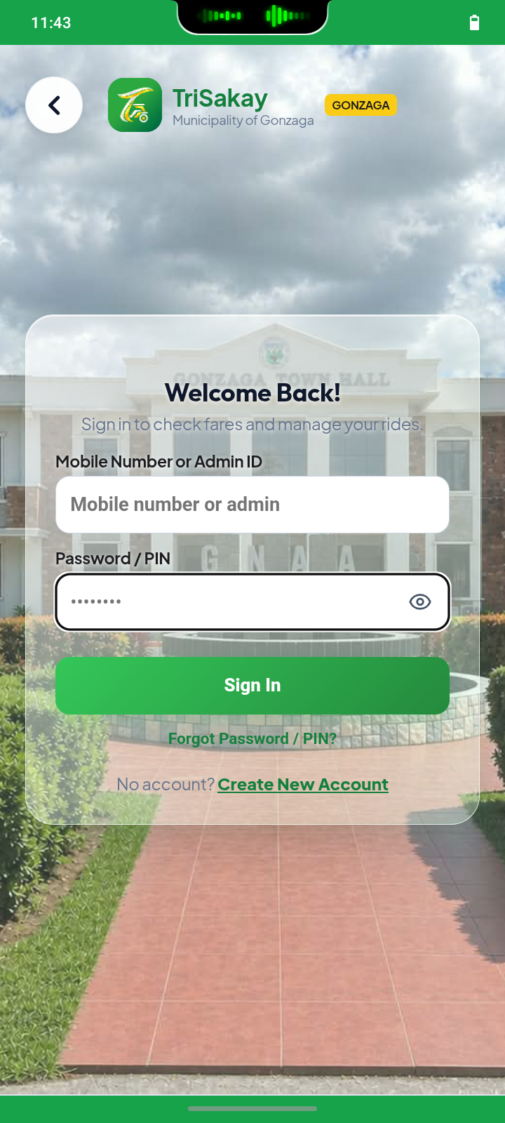

ADMIN MODULE
1.Account Setting can't be clicked and Barangay Detail is inaccurate.
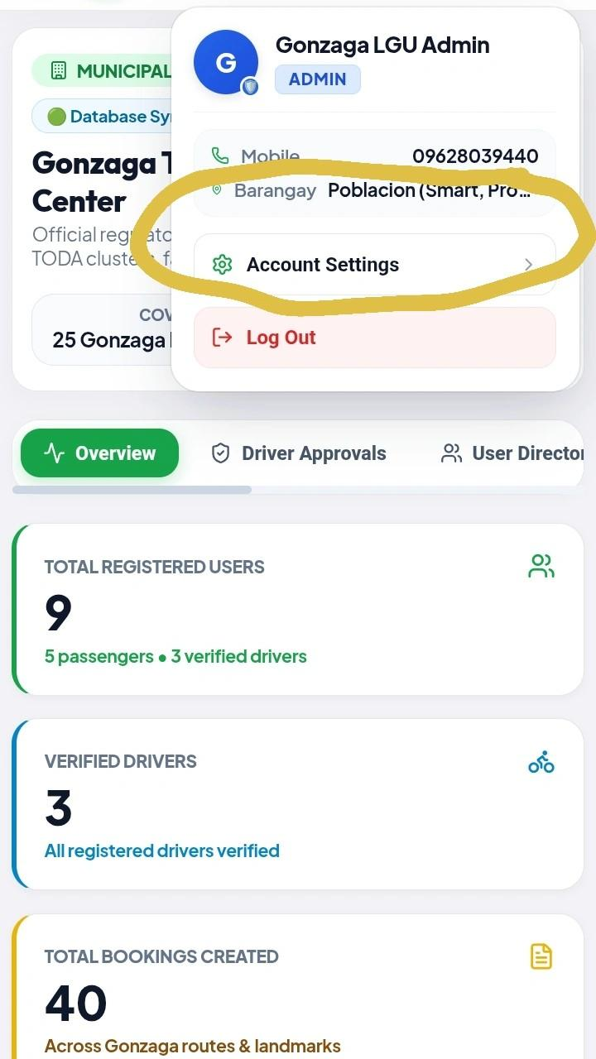

2.Use “Why Choose TriSakay” in both side navigator and page heading so they match exactly.
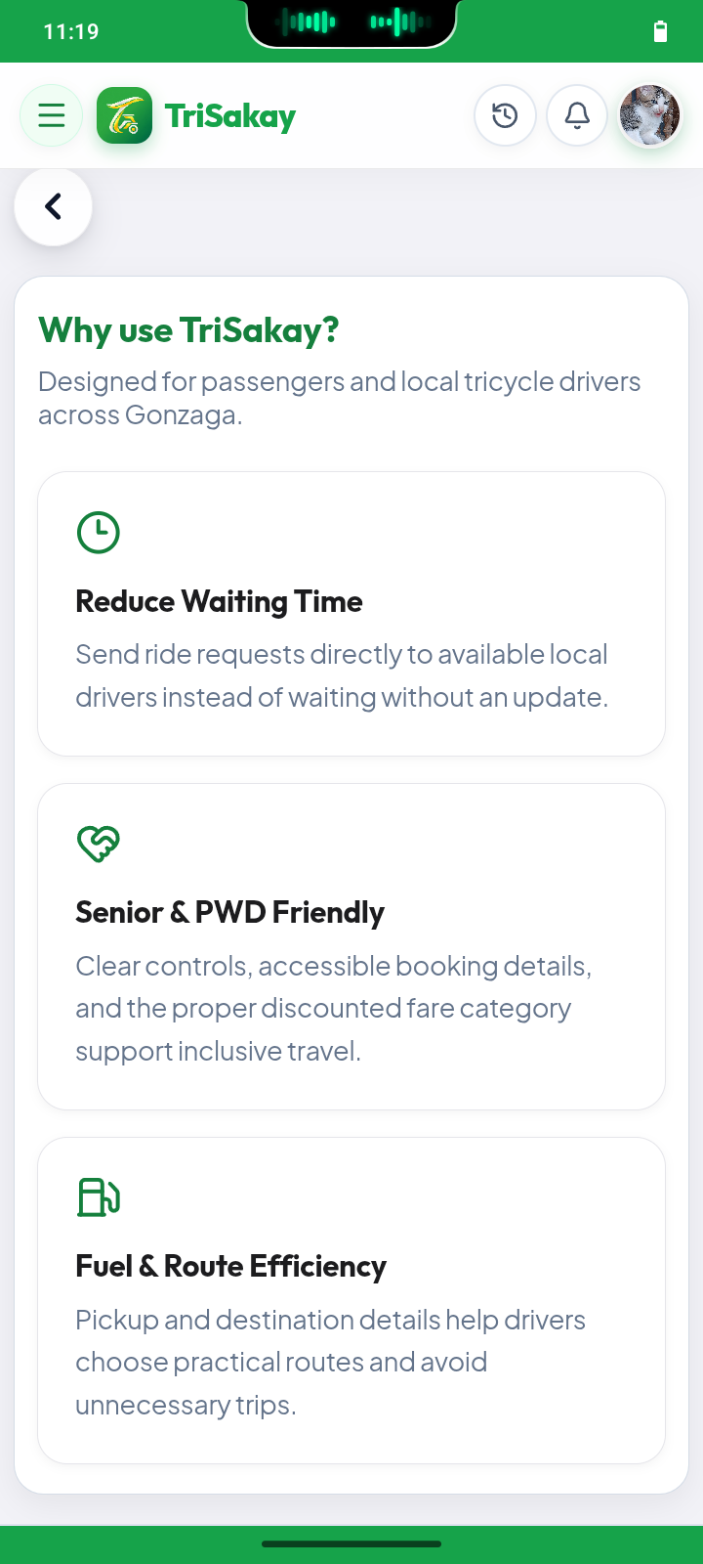
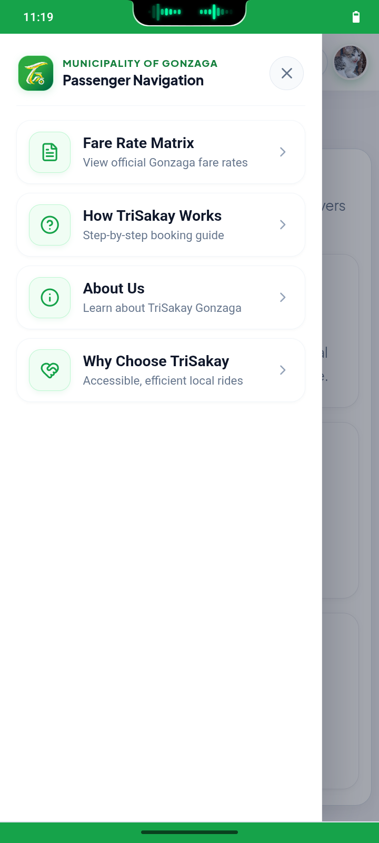

3. Under TODA CLUSTER section
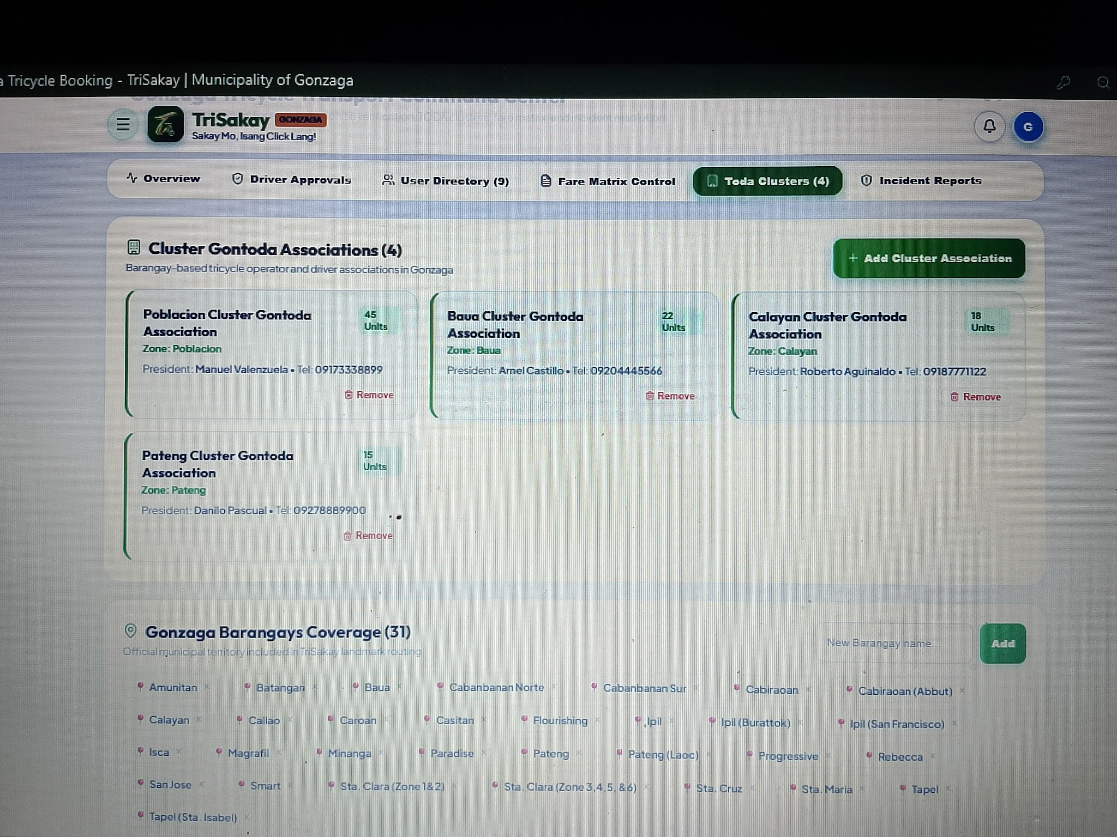

GONTODA Clusters (5)
Barangays grouped under each of the five color-coded clusters.
🔴 Cluster 1 — Red
Barangay Coverage
Flourishing, Paradise, Progressive, Smart, Sta. Clara
🟢Cluster 2 — Green
Barangay Coverage
Callao, Minanga

🔵Cluster 3 — Blue
Barangay Coverage
Amunitan, Batangan, Calayan, Ipil, Magrafil, Sta. Isabel, Tapel

🟡Cluster 4 — Yellow
Barangay Coverage
Cabanbanan Norte, Cabanbanan Sur, Caroan, Casitan, Isca, Pateng, Rebecca

🟠Cluster 5 — Orange
Barangay Coverage
Baua, Cabiraoan, San Jose, Sta. Cruz, Sta. Maria
Important Note: Change “Cluster GONTODA Associations (4)” to “GONTODA Clusters (5)” , and put this description “Barangays grouped under each of the five color-coded clusters.” Remove zone, and the President's name and mobile number as we do not have info. about that yet.

Barangay TODAs (25)
List of individual barangay-level tricycle operators' associations.
- Amunitan TODA
- Batangan TODA
- Baua TODA
- Cabanbanan Norte TODA
- Cabanbanan Sur TODA
- Cabiraoan TODA
- Calayan TODA
- Callao TODA
- Caroan TODA
- Casitan TODA
- Flourishing TODA
- Ipil TODA
- Isca TODA
- Magrafil TODA
- Minanga TODA
- Paradise TODA
- Pateng TODA
- Progressive TODA
- Rebecca TODA
- San Jose TODA
- Smart TODA
- Sta. Clara TODA
- Sta. Cruz TODA
- Sta. Maria TODA
- Tapel TODA
Important Note: Change “Gonzaga Barangays Coverage” to “Barangay TODAs (25)” , and put this description “List of individual barangay-level tricycle operators' associations.” Do NOT include the President's name and mobile number as we do not have info. about that yet.

PASSENGER MODULE
1. Increase Text Size (dating senior button) – Use " A+ " as symbol.
2. Passenger Limit – 6 passenger maximum
3. Add Flourishing (CSU) in one of the choices when a passenger books a ride. Include this in Fare Matrix Estimator, and Pick-up & Destination. It must be placed after " Flourishing”.
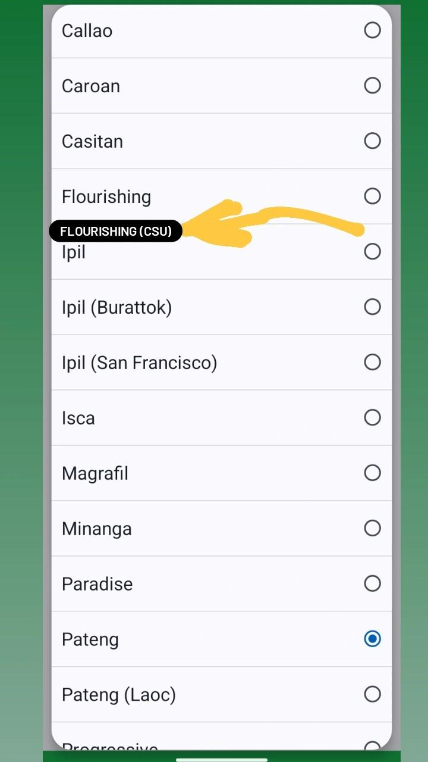

4. Use “Why Choose TriSakay” in both side navigator and page heading so they match exactly.

4. Include Rate Category (Senior/Student/PWD Rate or Regular Fare Rate) on Check Fare Estimate below/beside the “Book A Ride Now” feature for more accurate fare estimate.

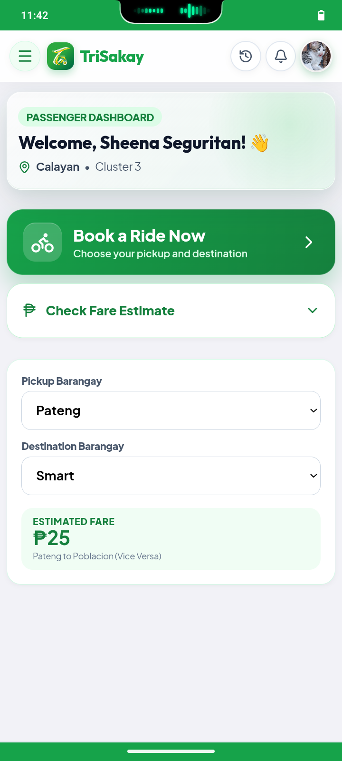

DRIVER MODULE
1. Increase Text Size (dating senior button) – Use " A+ " as symbol.
2. Passenger Limit – 6 passenger maximum
3.Add Flourishing (CSU) in one of the choices when a passenger books a ride. Include this in the Fare Matrix Estimator. It must be placed after " Flourishing”.

4. In the driver's registration process, include 'Barangay TODA' as an alphabetical dropdown selection (available above). Selecting a Barangay TODA (e.g Calayan TODA) must automatically identify and assign its corresponding cluster (Cluster 3). Therefore, Name, Mobile Number, Barangay, Barangay TODA (that automatically identifies which cluster that Barangay belongs to) Tricycle/ Plate Number, and password, must appear in the driver's registration process. (Reason: Pwedeng maging member ng ibang Barangay TODA ang isang driver kahit taga ibang Barangay siya).
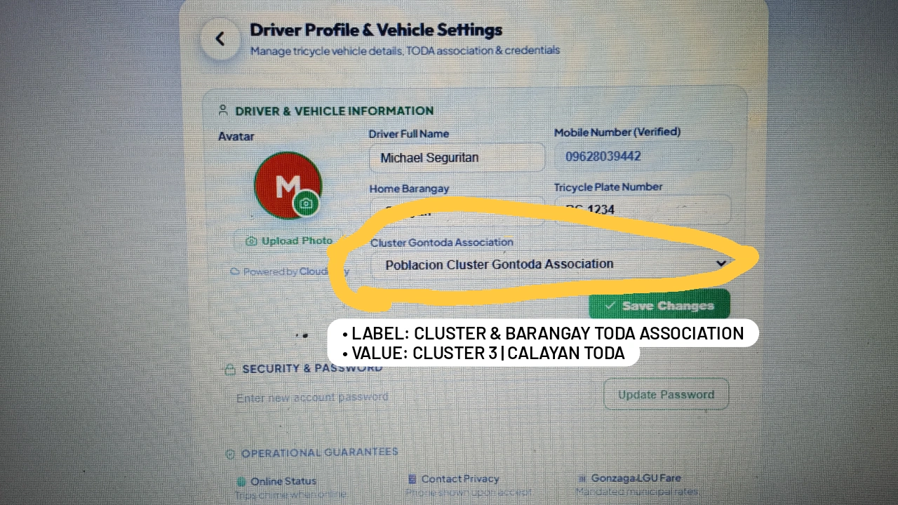
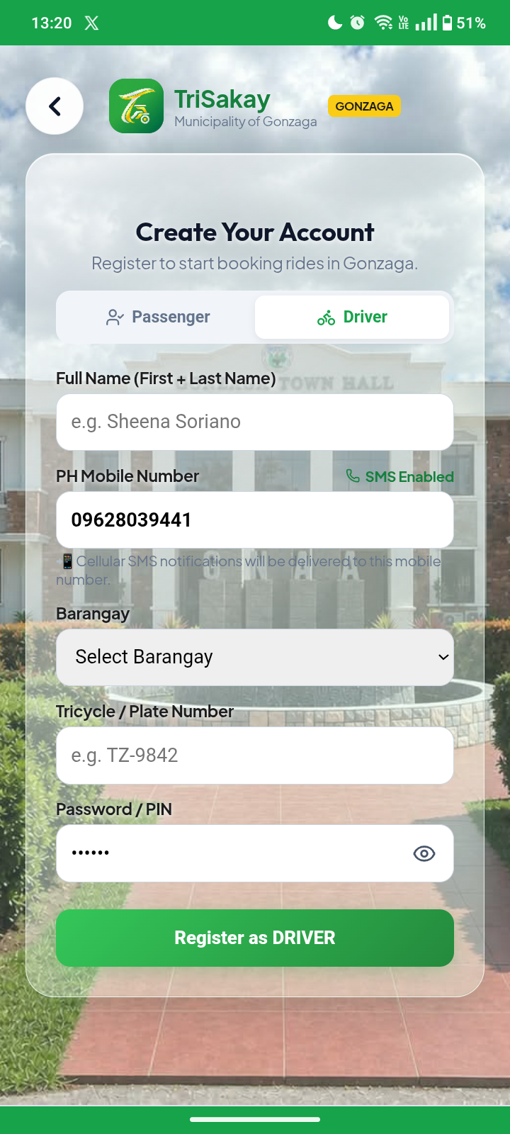

5. Cluster group cannot be identified (appears “Not Specified”) during Admin’s review for approval.
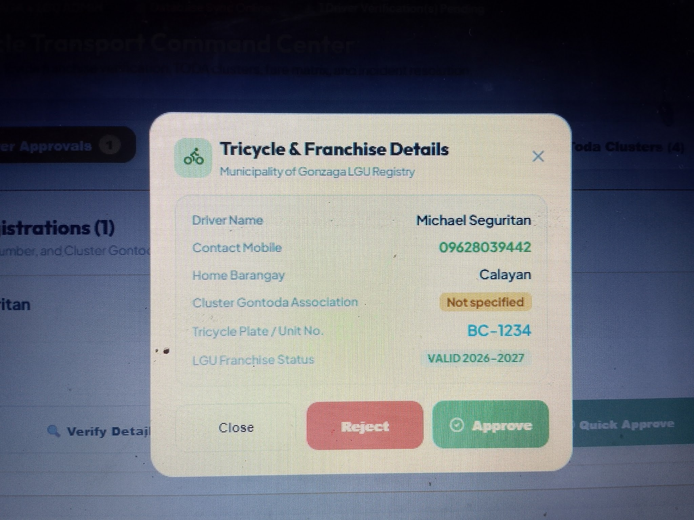

6.Use “Why Choose TriSakay” in both side navigator and page heading so they match exactly.

7. Change booking acceptance time limit to 45 seconds to allow drivers to pull over or read the booking information with more time while especially when driving.
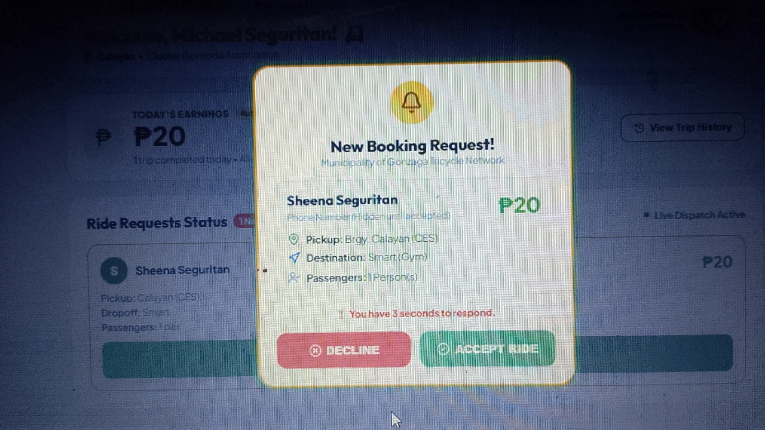

8. Report Issue must only appear after the ride is completed to avoid duplication of incident reports in the Admin's Incident Reports section. Put the report issue below the rating, and then click “Submit”. Retain “Skip for now”.
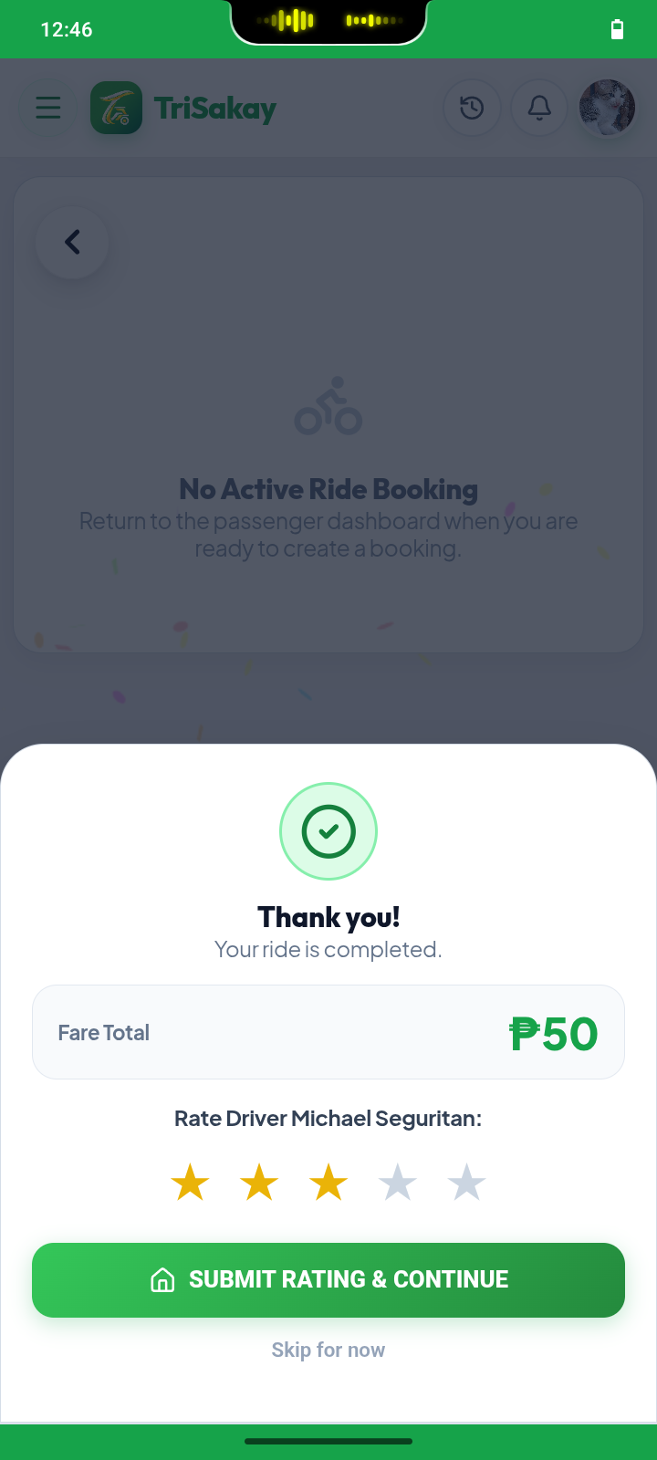
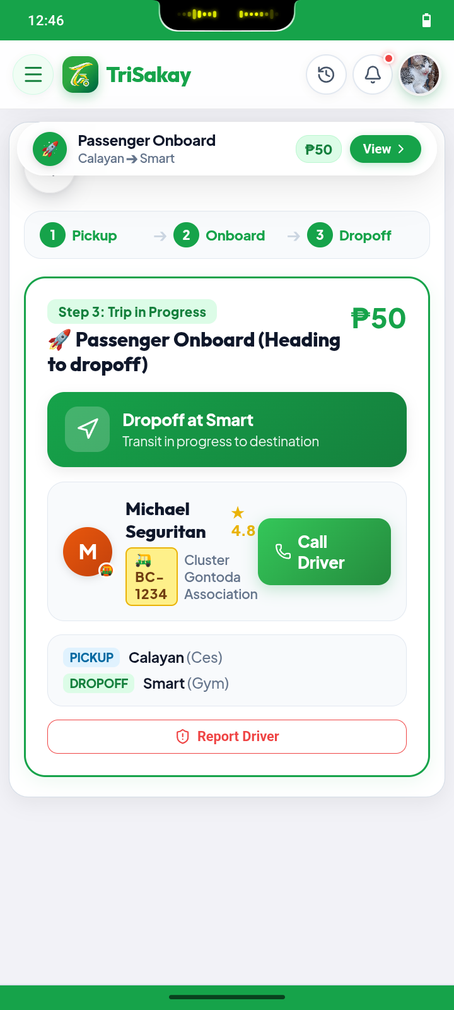

9. When the passenger clicks the “I'm Waiting” feature it does not appear/ update on the driver’s dashboard.
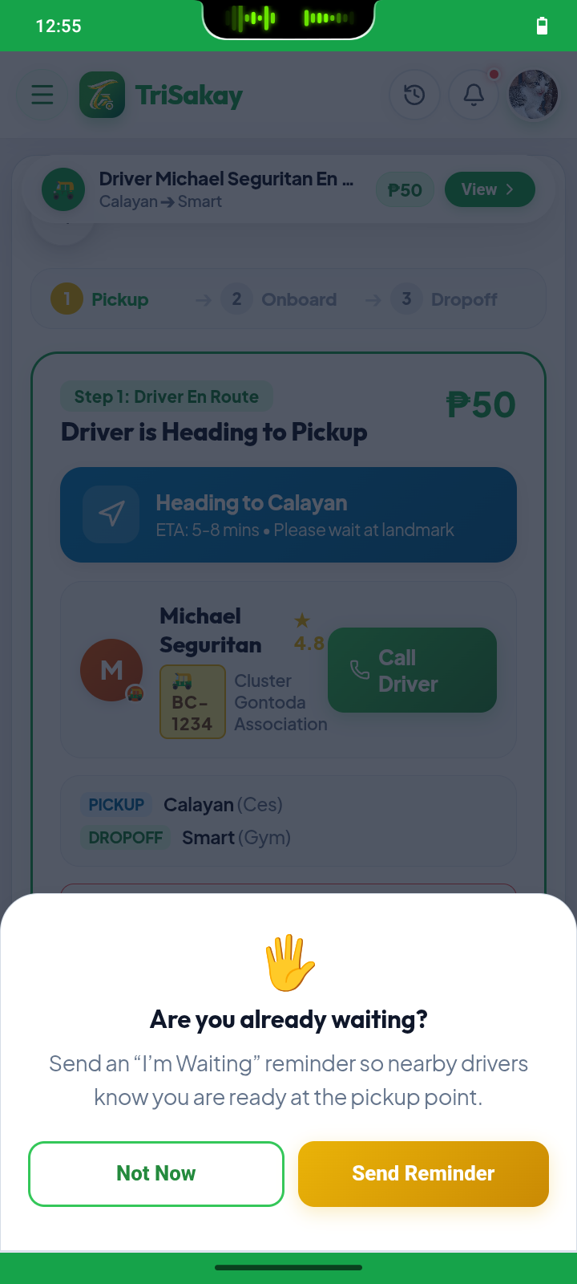

10. rovide a button for drivers to reset “Today's Earnings” to zero for the next day.

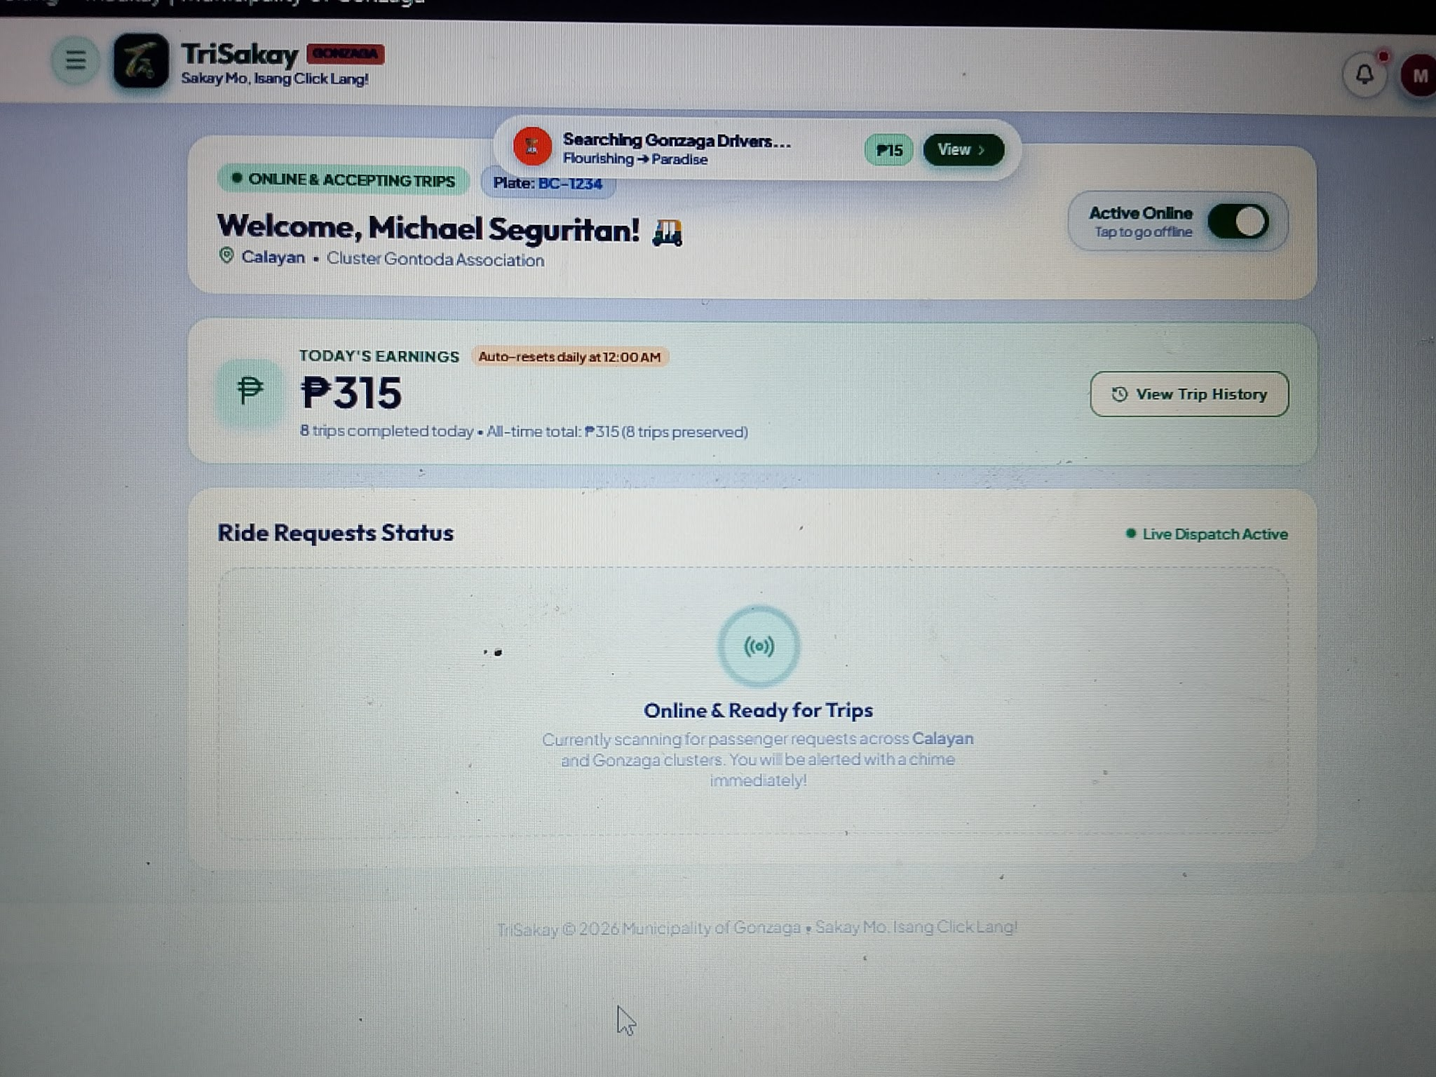

MOST IMPORTANT

11. Issue: Every driver who is online (even from other Barangay TODA) can receive the notification every time a passenger books a ride. Therefore, we should replace this part of the open booking system with a Priority-Based Booking Notification System. This system will give drivers within that Barangay the first chance to accept a ride before offering it to others.
- Step 1 (Drivers w/in that BRGY.): When a passenger books a ride, only online drivers from that specific pickup Barangay's TODA get notified.
- Step 2 (Same Cluster): If no driver from that Barangay accepts within a set time (45 seconds), the alert expands to drivers in nearby barangays within the same cluster.
- Step 3 (Other Clusters): If still no one accepts, the alert goes out to all remaining drivers in other clusters.
- Step 4 (First-to-Accept Rule): Only one driver can win the booking. The exact moment a driver accepts, the ride is locked, other drivers' notifications disappear, and the system stops looking.
- Step 5 (No Driver Found): If no driver accepts after all steps, the passenger is notified to retry or cancel.
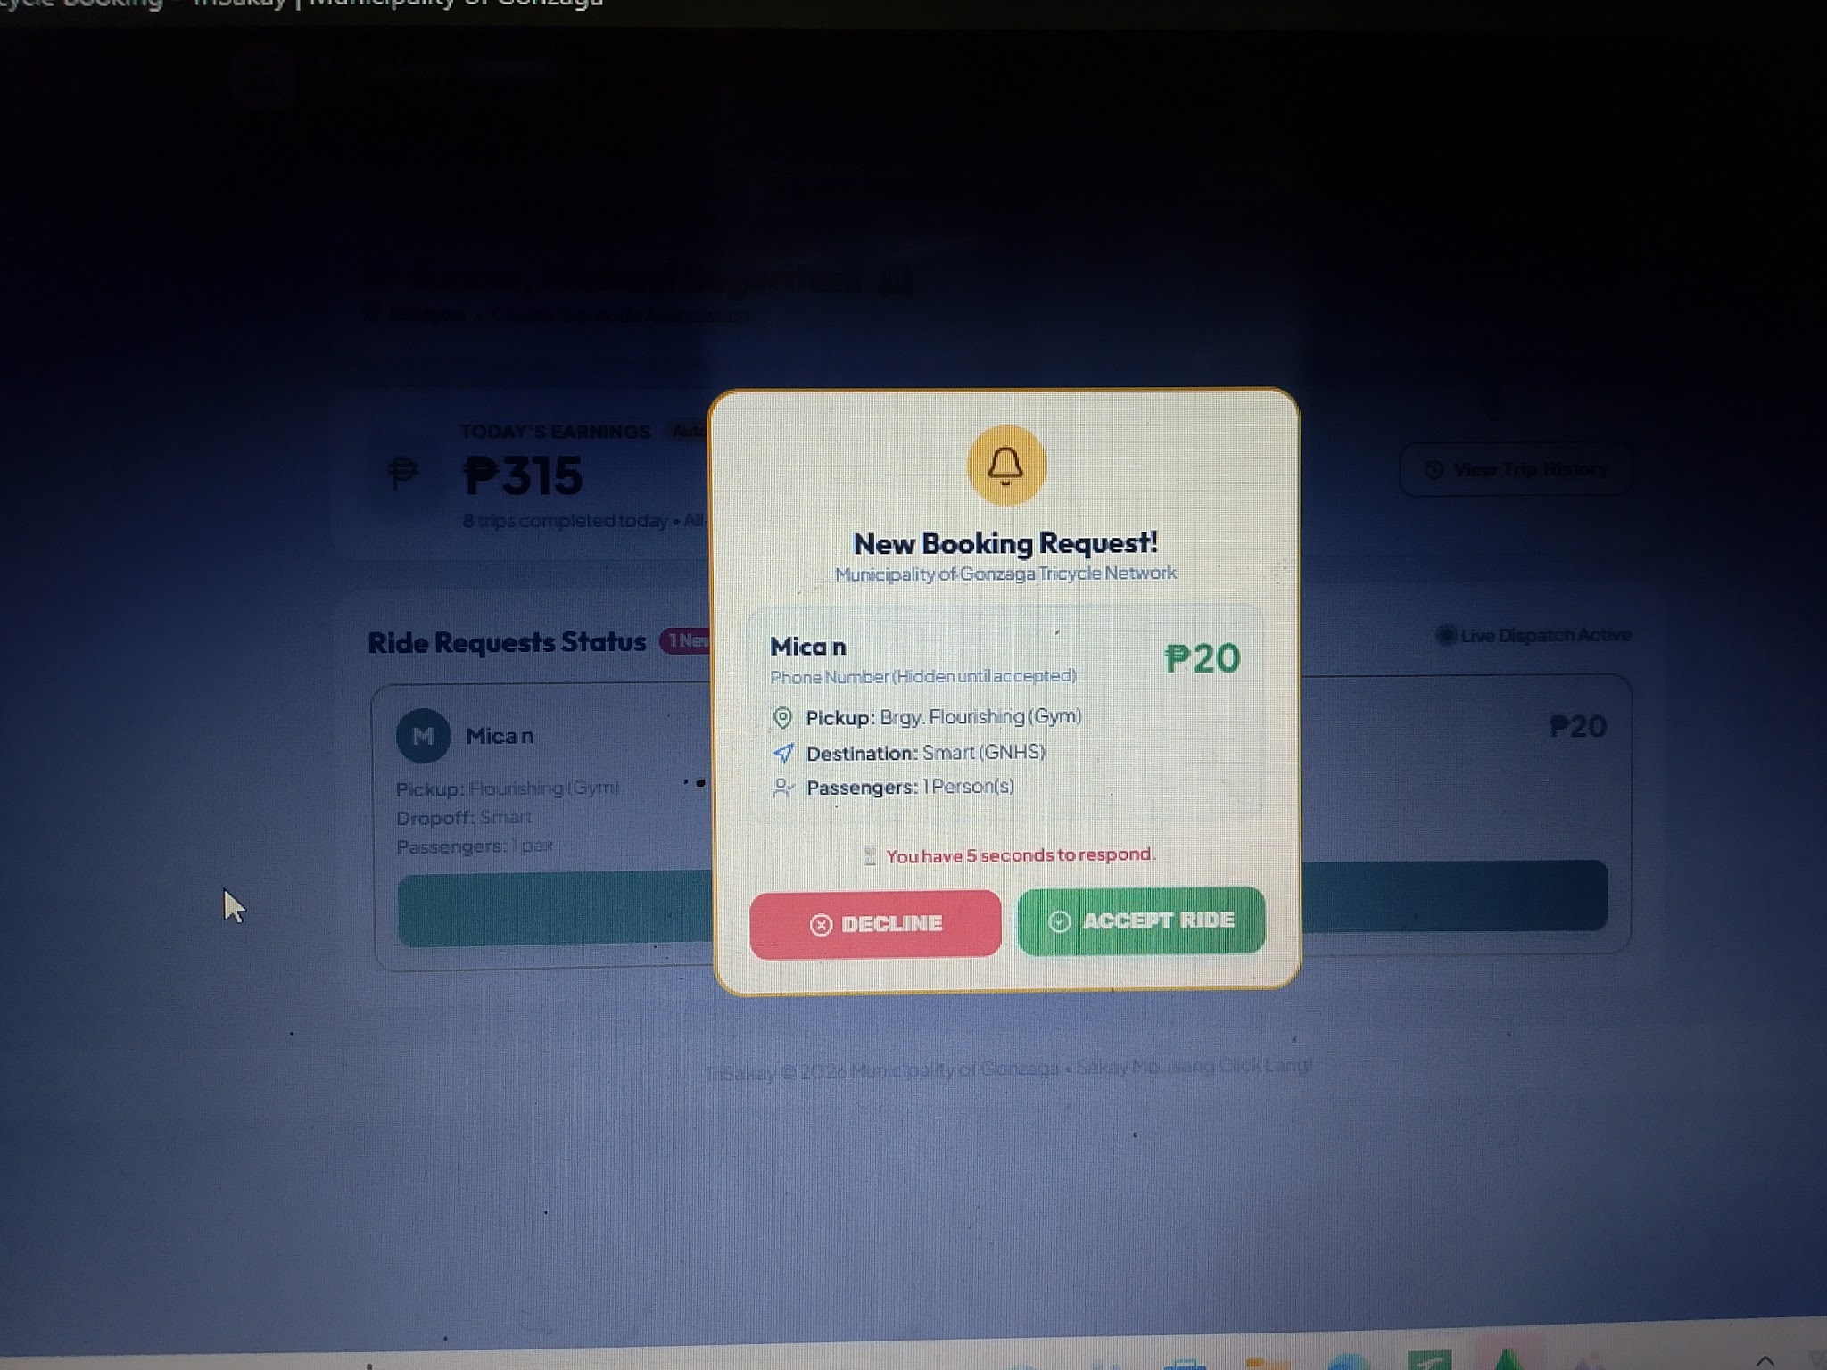
- Step 6 (Driver Rules): Driver priority is based on their registered Barangay TODA and cluster, not just their online status.

